Academic Year:  2019/2020 |  | Total fund allocated:  £17260
PE and Sport Premium Key Outcome Indicator | School Focus/ planned Impact on pupils | Actions to Achieve | Planned Funding | Actual Funding  £17,260 | Evidence | Actual Impact (following Review) on pupils | Sustainability/  Next Steps
1. the engagement of all pupils in regular physical activity – kick-starting healthy active lifestyles | Children engage in 2 hours of curriculum PE per week.  ‘Move more’ an additional 30 minutes exercise a day.  .  Annual Membership Fee for Sheffield Federation for School Sport membership | Continue with ‘change for life’ clubs (ultimate Frisbee, jump rope, healthy eating)  Trained Year 6 pupils as play leaders to set up and manage different sporting and fitness activities during lunchtime which will encourage all pupils to participate in 30 minutes of activity during lunchtime.  Purchased Play Leader sweatshirts  Promote ‘healthy schools week’ by running different activity ‘taster’ sessions.  Spare PE kits to be made available to ensure all pupils are participating in all PE sessions.  Access to inter school competitions | £800.00  £200.00  £100.00  £200.00  £100.00 | £800.00  £200.00  £100.00  £200.00  £100.00 | Increased participation in extra-curricular activities, especially with children that have been identified as ‘inactive’. | Increased numbers of new arrival children understanding what healthy diets are. Evidence in lunch boxes.
2. the profile of PE and sport being raised across the school as a tool for whole school improvement | All pupils will make good or better progress in PE. Children will be enthusiastic about taking part in PE and sport both within the curriculum and extra-curricular activities. | Supply teacher to allow PE coordinator a day each half term to organise competitions, review progress against the action plan and to observe lessons.  Additional supply cover to release subject leader to attend sports events. | £1200.00  (£200) each day)  £1200.00 | £1200.00  £1200.00 | Children are physically literate, competent and confident movers, who show good SMSC and British Citizenship attributes.  Pupils talk enthusiastically about PE lessons and extra curricular sports clubs they are participating in. | Increased number of children demonstrating healthy lifestyles
3. increased confidence, knowledge and skills of all staff in teaching PE and sport | Continue to develop existing and new staff members with targeted CPD | Purchase the Arches Platinum package plus Forge Valley Cluster Competition Programme, choosing the option for up to 15 members of staff to access CPD programme places to increase staff confidence and knowledge in what each staff members deems as an area of development.  Continue team teaching with a qualified coach  Whole staff training on how to structure PE sessions using the same criteria for classroom lessons.  Partnership games T-Shirts & Afterschool club coaching  Cricket Coach for 2 classes for half a term & After school clubs | £2785.00  £500.00  £125.00  £450.00 | £2785.00  £500.00  £125.00  £450.00 | Drop in to PE sessions to ensure lessons are structured in a similar way to classroom lessons.  Staff questionnaire focussing on increase in staff confidence in delivering PE sessions. | Upskilled staff.  School to achieve Gold award for the School Games  PE subject leader to work with Arches to further develop skills in leadership.
4. broader experience of a range of sports and activities offered to all pupils | Increase the variety of extra-curricular school clubs  Improve provision further by introducing new sports. | Arches extra-curricular clubs to include a wider range of less traditional activities.  Participate in Arches partnership games.  Year 5 to participate in bikeability training, staff cover costs.  Develop links with two local sports clubs/organisations.  Gymnastics Club throughout school including badge scheme.  Karate lessons for Y2 – Y6 pupils including gradings  Purchase of PE & Playtime Resources | £1600.00  £400.00  £2000.00  £1000.00  £2200.00 | £1600.00  £400.00  £2000.00  £1000.00  £2200.00 | Children gain an experience in a broad range of sports and activities.  Give children exciting new resources for playtime.
5. increased participation in competitive sport | Increase the number of children participating in competitive sport with at least:  6 teams competing at intra-school sports  4 teams at inter-school sports (netball, dodgeball, football and athletics)  Participate in DSAT Games at EIS | Enter all appropriate inter-schools competitions organised by The Arches. Ensure that staff are aware of the competition timetable.  Cover the cost of transport to events | £2000.00  £400.00 | £2000.00  £400.00 | Increase in children attending competitive sporting events regularly throughout the school year.
Total Spend £17,260
Completed by: Yvette Hawksworth

Developed by

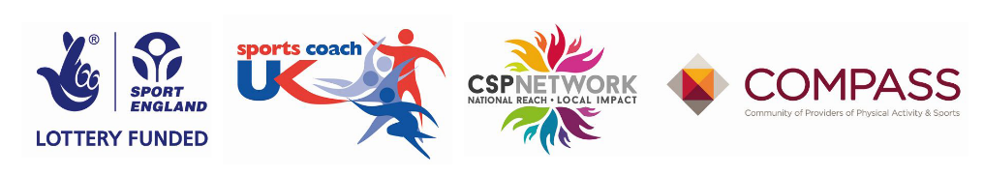
Date: 21.11.19
Review: Termly

